Consider, We have a data set which hold the Co-Ordinates.Fig 1 :- 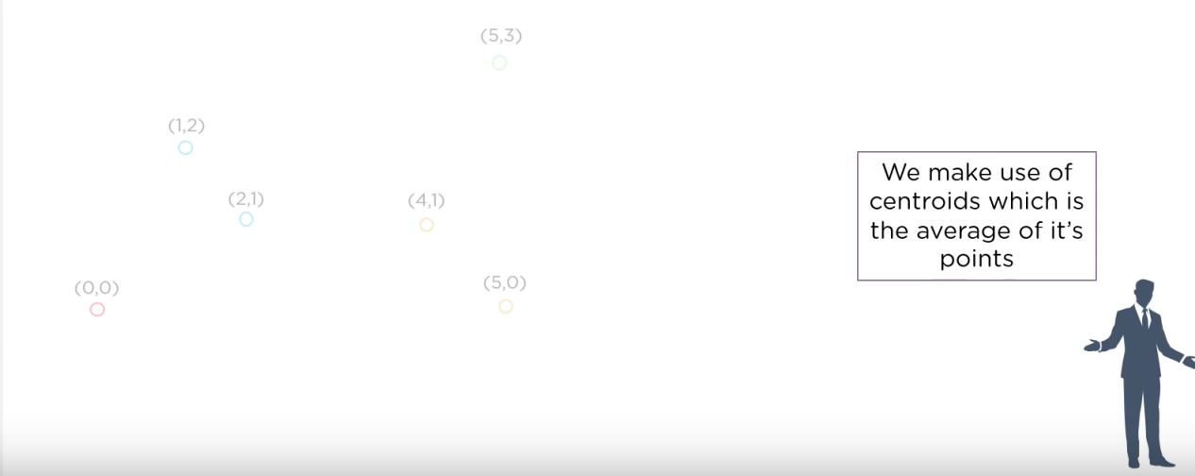

Now, We take any 2 random points and try to get the centroid Co-ordinate. Once Using 2 points when we join them into a different group. That Separate group is known as Cluster.

Now, As we can see in following Diagram, We have made 2 Clusters. Fig 2 :-

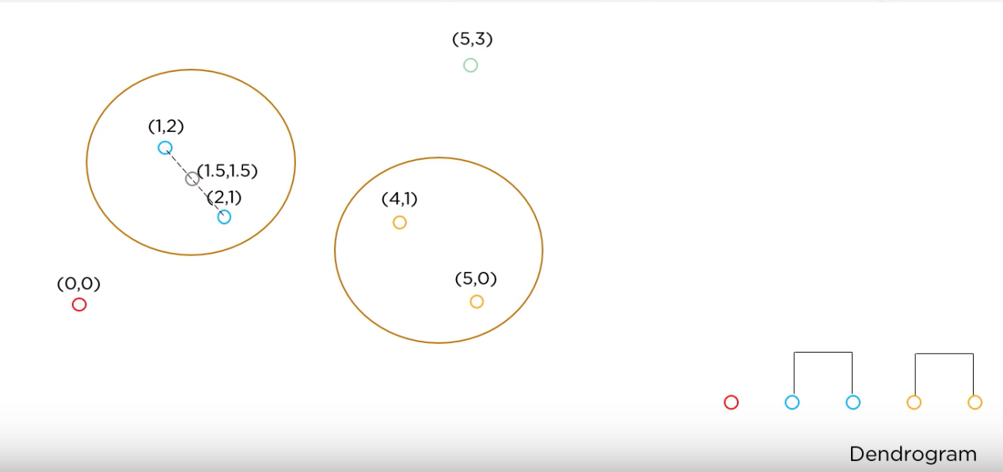

Now, Using already made cluster we will join the nearest Independent point/ Cluster near to the Cluster.

Note :- Points are in high priority while increase the size of cluster and grouping multiple cluster into one.

As we can see, We are again Considering centroid in new following Diagram, Fig. 3 :-

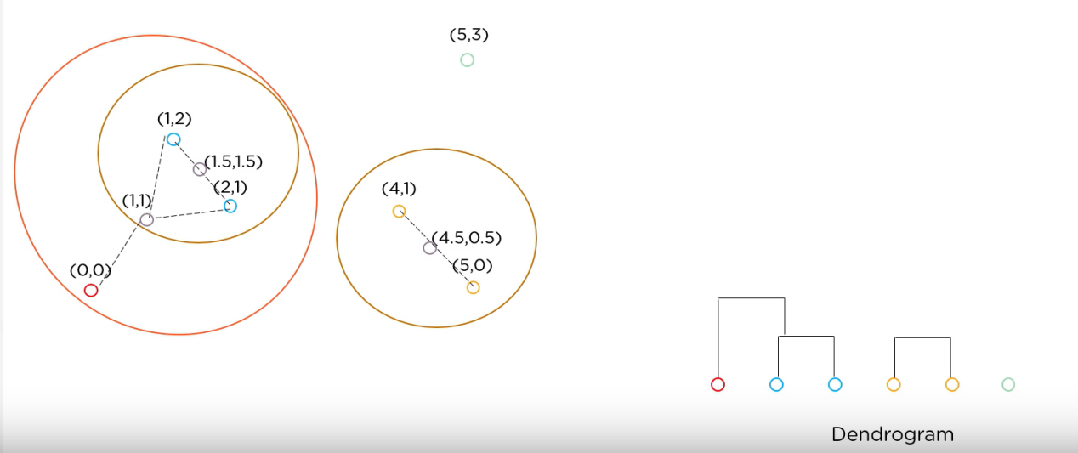

Now, Again a new Cluster Formed with the Point( Independent Points having high priority than cluster. )

Fig 4 :-

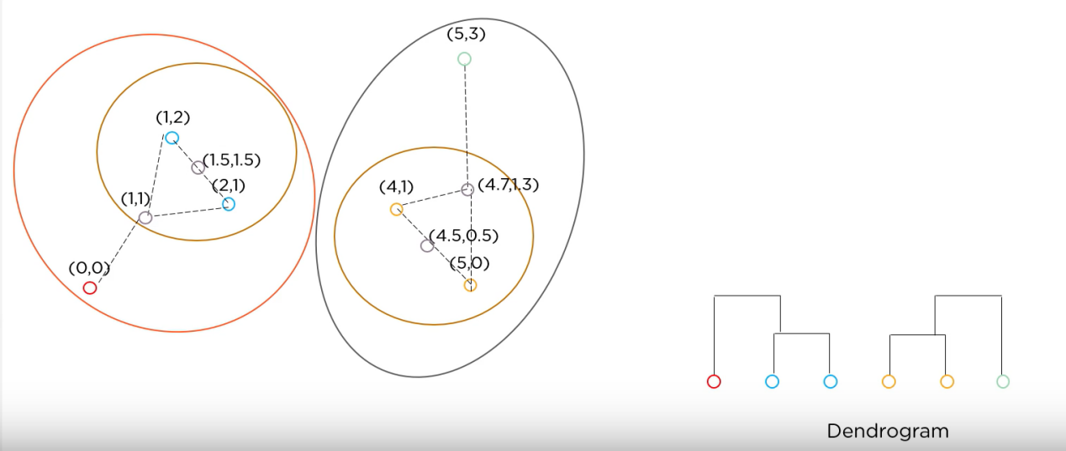

At last when we have no independent point(s). Then, we are ready to join 2 cluster one by one. Till all the cluster gets grouped into one final Cluster as shown in Following Figure,

Fig 5 :-

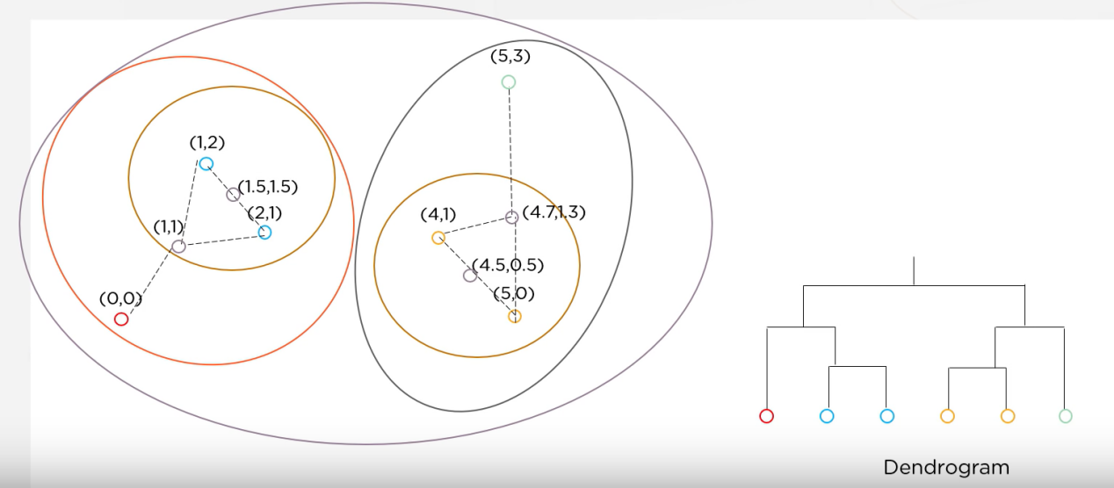

As we can see in Figure 4, we had no independent points. So, we started searching for the Cluster and then, at last we have joined the nearest cluster one by one same as point addition method.

We can See a graph Here also. So, This Graph pattern is knows as Dendrogram which means, formation of something with the help of the existing Figure.